LIBIL Issues

1] In "Linked in" and "Corporate Bio". Field showing Enter Pan No. and Enter GSTIN number

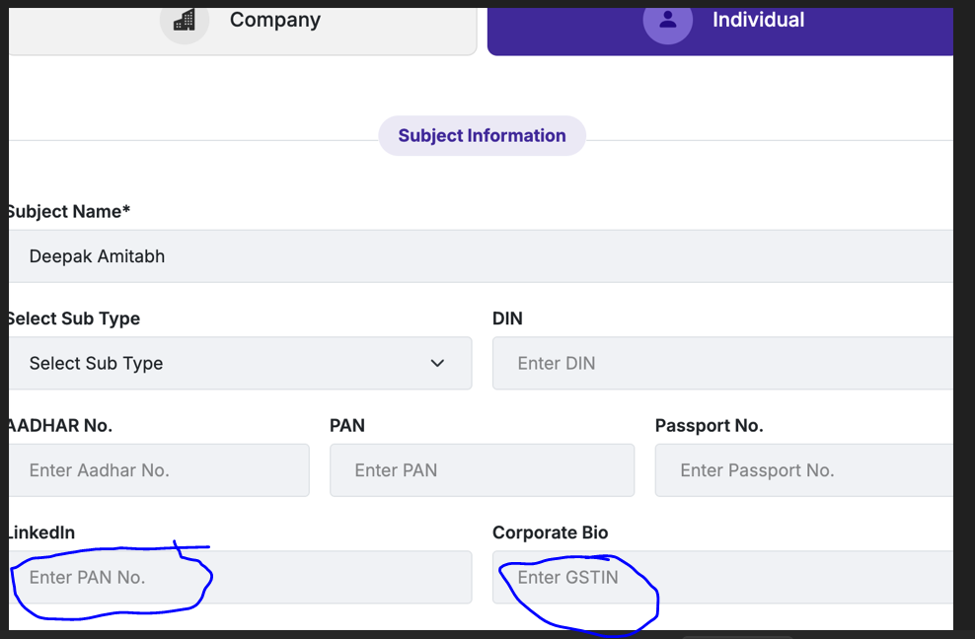

2] When I do this - Bijay w/20 Quest this case is not coming under Proximity.  
is it because there is no space so Agarwal, quest is considered as one word.

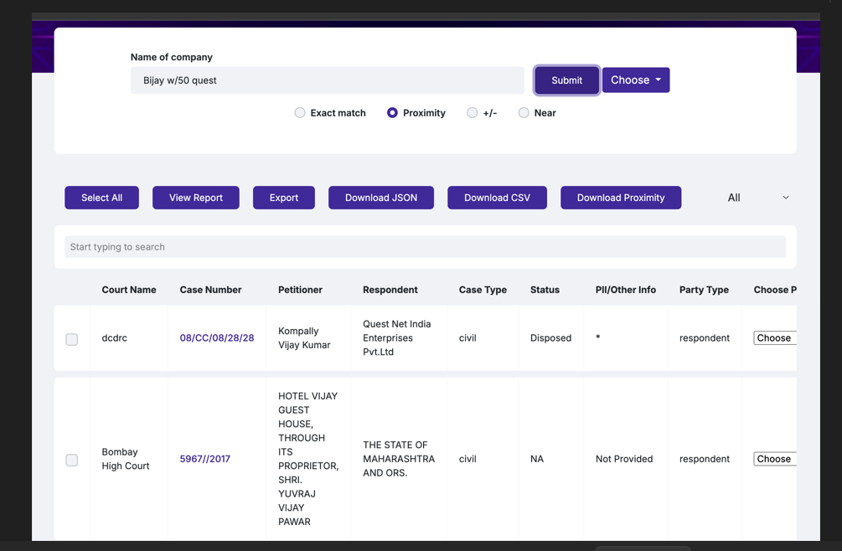

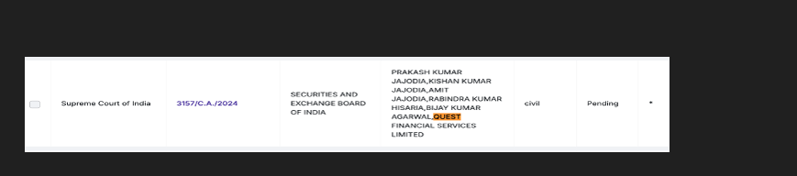

3] When I am searching for  
Nab - it not showing results for NABS.  
When searching "Nabs Vridhii" - only showing 9 result. It is not showing any result with Vridhii, only showing cases with NABS and not even including variations for NAB.

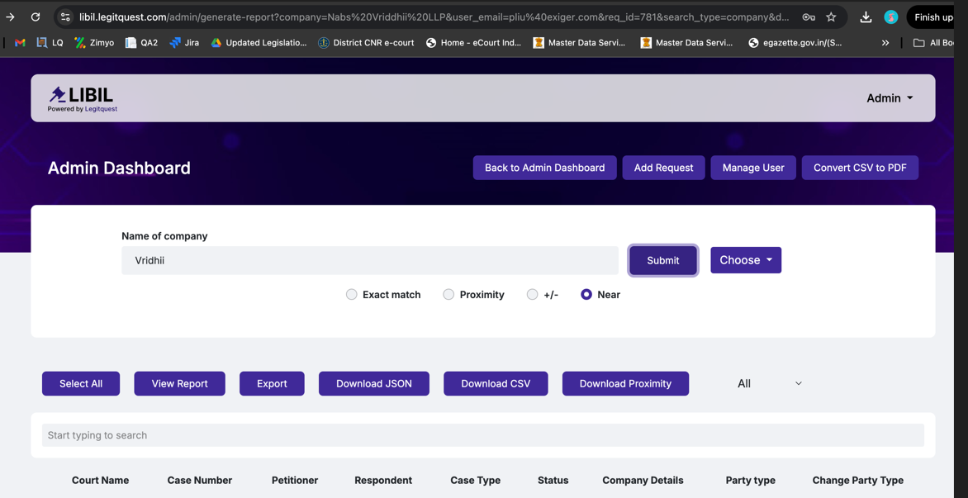

4] If I search for any of these words, all the variations should be shown in NEAR. It shows some result on Patrol but not on LIBIL, showing zero.  
Vriddhii -   
Vridhi  
Vruddhi  
VRIDDHi

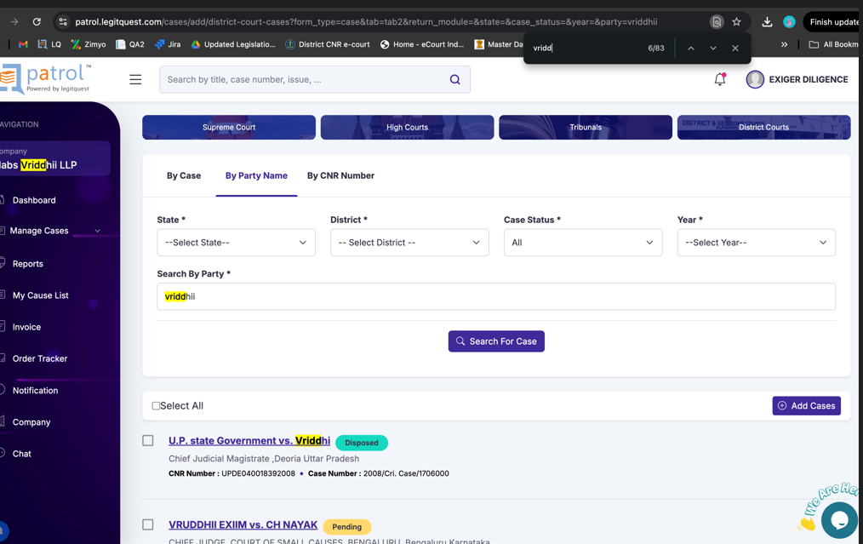

5] Same issue with this search result -  
"Neelanchal" - no result coming for "Neelachal" or neelanchala or neeranchal